Configure Faculties to capture Score

- From Front End

Step 1 Go To CMS >> Exam n Grading >> Settings >> Click on Configure faculties for marks capture
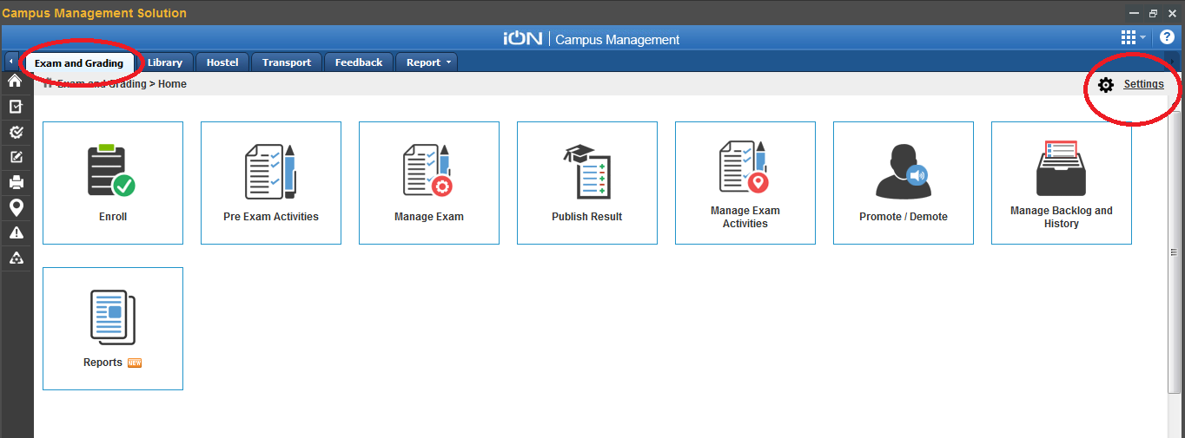
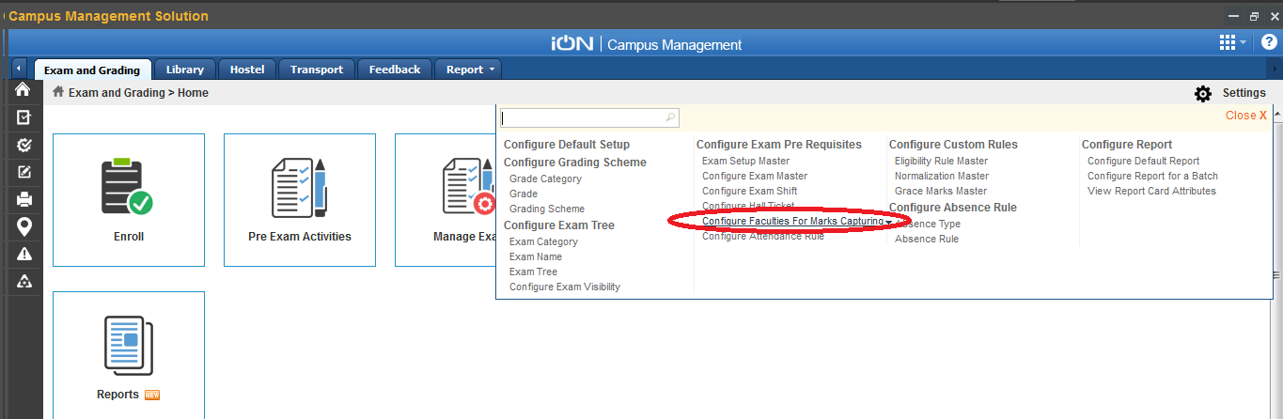

Step 2 Click on Create
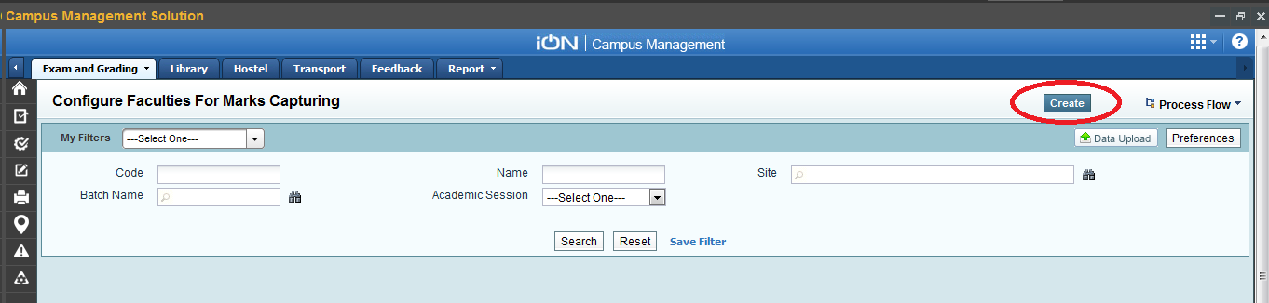
Enter the Details of the batch for which you want to configure faculties to capture score
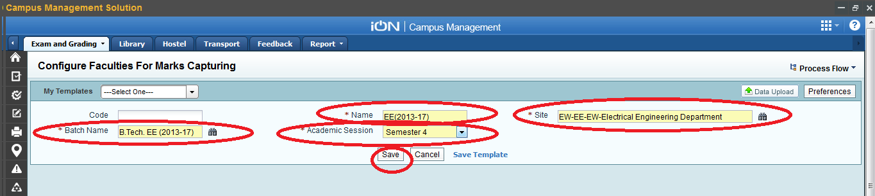

Step 3 Now tick check box all exam and select the subject for which you want to configure faculties to capture score.
You can click on add row for more subjects to be added .

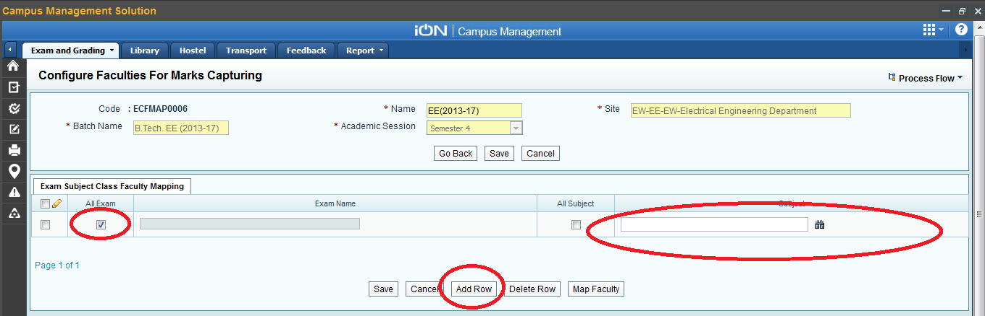

After adding all the Subjects click on Save.
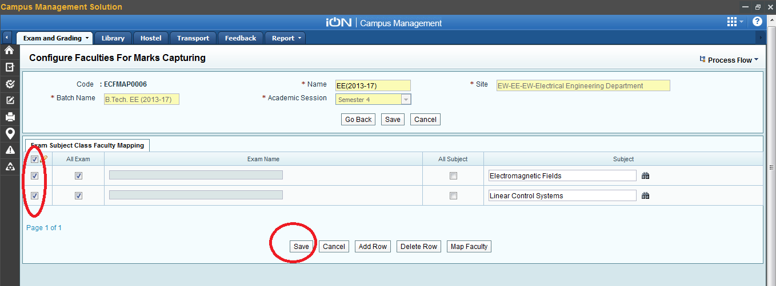

Step 4 To map faculty who will capture score against a subject , select the subject and click on map faculty

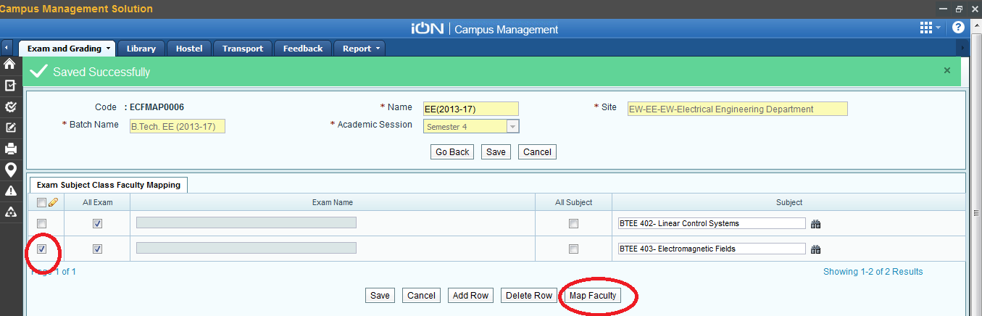

Select the class and faculty name who will capture marks against the subject for that particular class . You can add more classes by clicking on add row.
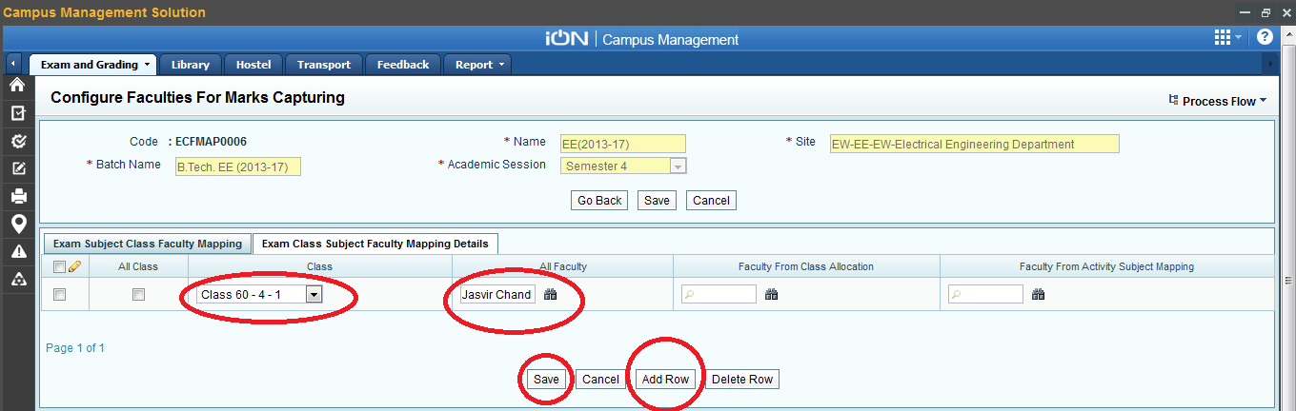

- From iON WebInstaller

Step 1 Go to iON WebInstaller

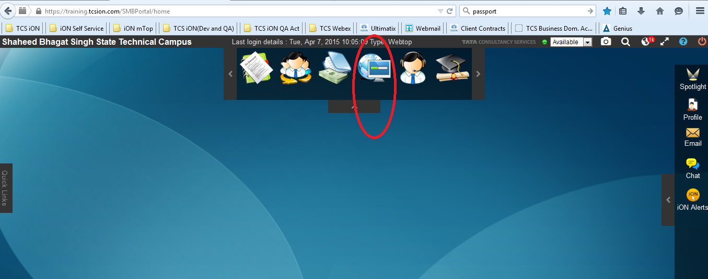

Click on Screen Search and type “Configure Faculties for Mark Entering”
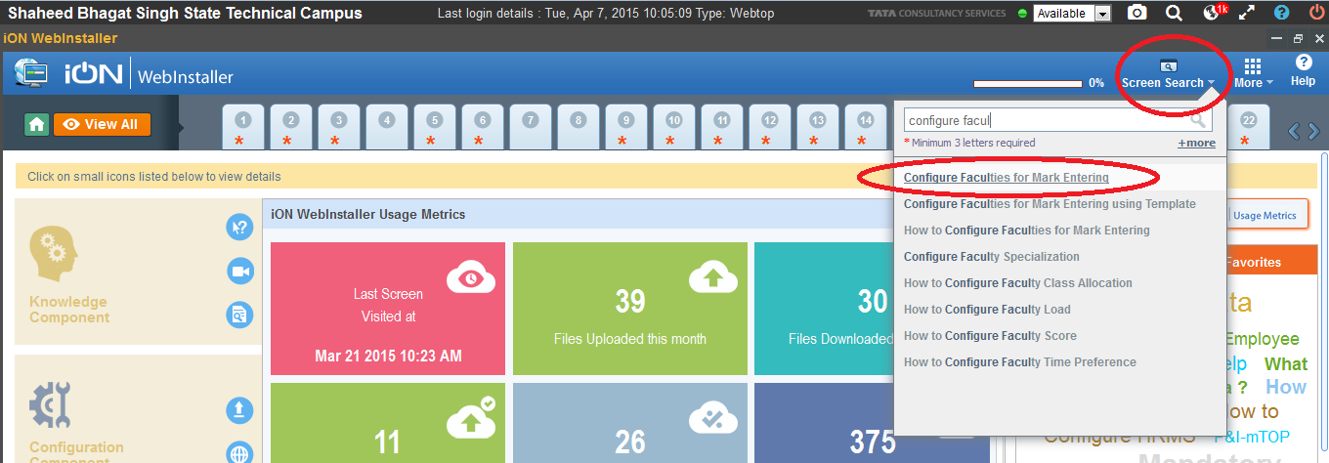
Click on the link
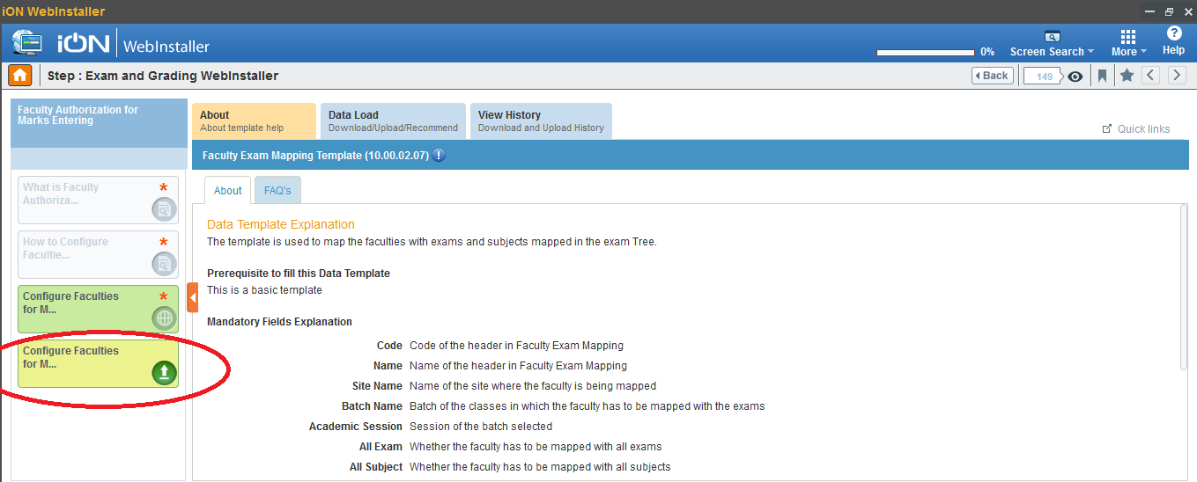
Click on Data Load and In Download Template , download Blank Template for creating a new template
Download Data Template if you need to make change s to an existing configuration in the system

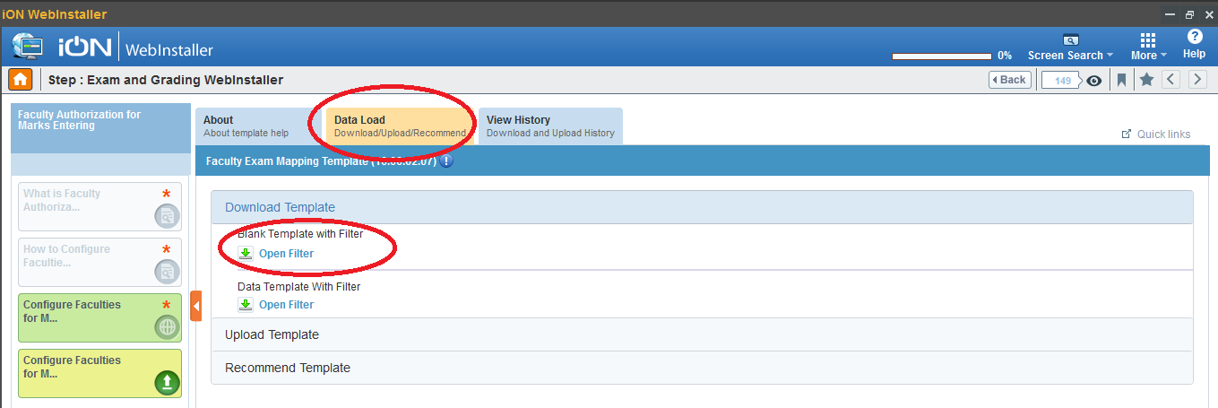
Enter the site, Batch and session for which you want to made configuration for capturing Score and click on Download
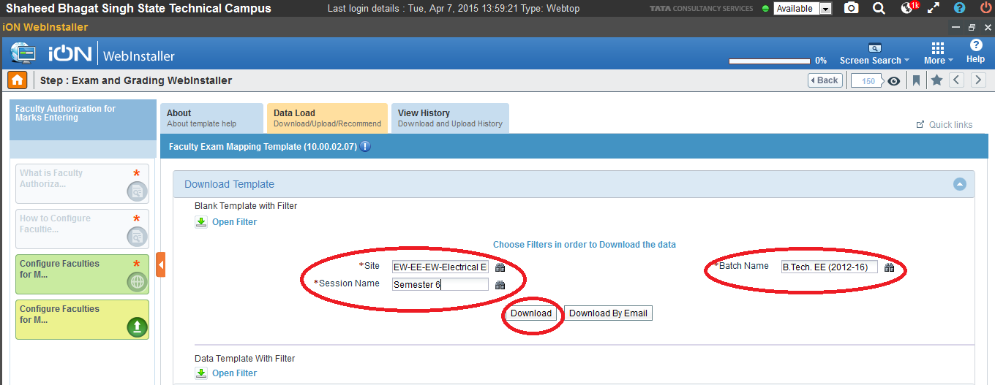
Then go to View History and click on Excel Link to download the template
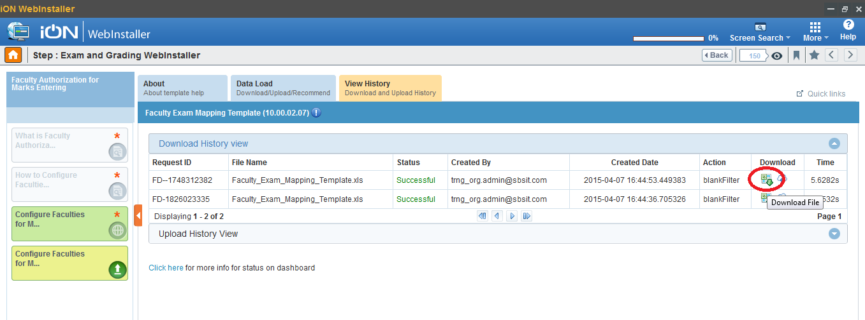
Fill the template as shown below for all the subjects for that Batch and Session
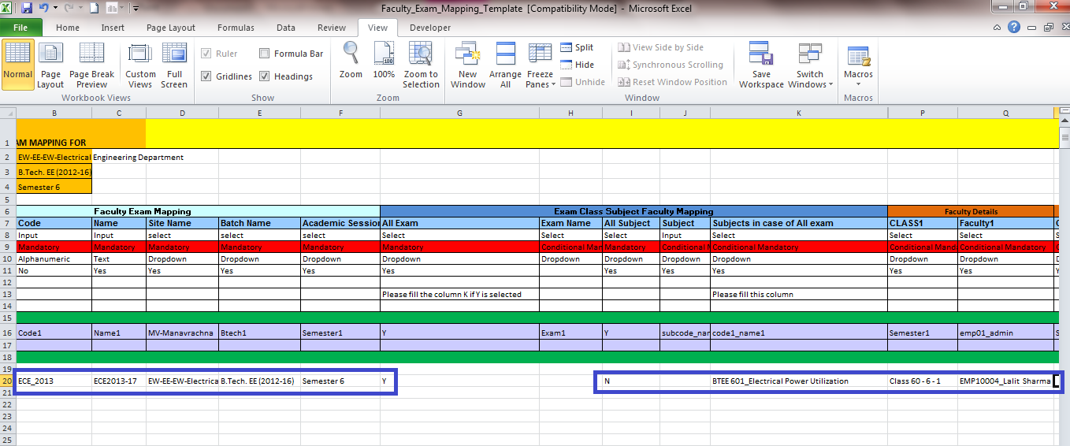
Then go to DATA LOAD and go to Upload Template
Enter the name for the template and from Browse select the file which you have filled for Upload.

Click on Insert if you are uploading it first time .
Click on Insert/Update if you have downloaded a Data Template and make some changes in it.
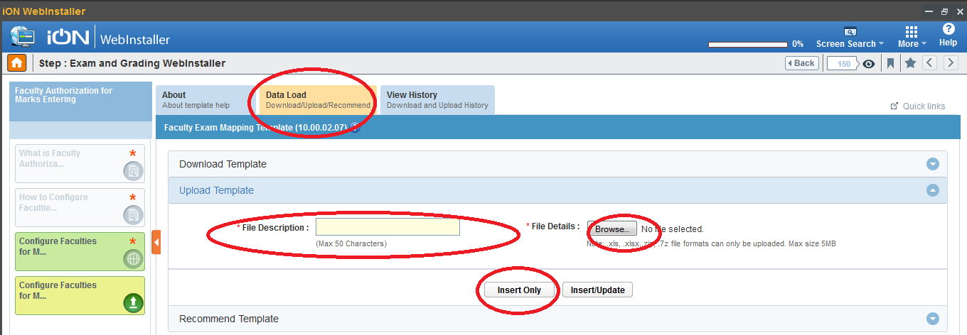
To check whther the template has been successfully uploaded or not .
Go To View history and check the status.
If status is successful then your file has been uploaded but if there is an error “ Validation Failed “ then check for the errors by downloading error log.


